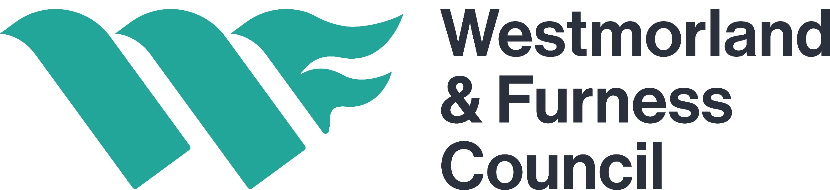
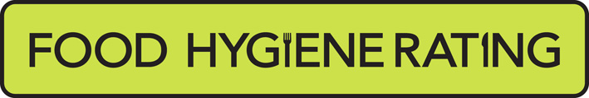
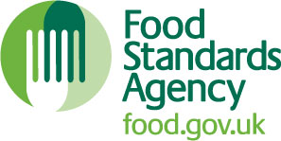
Food Hygiene Rating Scheme:
Request for a re-visit

Notes for businesses:

- As the food business operator of the establishment you have a right to request a re-visit for the purposes of re-rating if you have taken action to rectify the non-compliances identified at the time of inspection.
- There is no limit to the number of re-rating inspections you may request. However, to avoid paying for multiple re-rating inspections you should address issues before you submit a request. You can make this at any time after the statutory inspection provided that you have made the required improvements.
- You must provide details of the improvements made with your request, including supporting evidence where appropriate.
- If the local authority considers that you have provided sufficient evidence that the required improvements have been made a re-visit will be carried out within three months of the receipt of your request and payment of the fee.
- The local authority officer will give you a ‘new’ food hygiene rating based on the level of compliance that is found at the time of the re-visit - you should be aware that your rating could go up, down or remain the same.
- To make a request for a revisit, please use the form below and return it to the Lead Officer for Food. Contact details are provided below.
Business details
Food business operator/proprietor

Business name

Business addresses
Business tel. number |  | Business email

Inspection details
Date of inspection |  |  |  |  |  | Food hygiene rating given

Action taken
Please describe the remedial action you have taken with reference to the issues identified in the inspection letter/report provided to you by your local authority with your score:
Compliance with food hygiene and safety procedures

Compliance with structural requirements
Confidence in management/control procedures

Please provide any other supplementary evidence (e.g. photographs, invoices, copies of relevant HACCP documentation etc.).

Signature
Name in capitals
Position |  |  |  |  |  |  |  |  | Date
Once completed return the form to the anchor building that covers your business area (your previous Local Authority) below:

Barrow area:  Westmorland and Furness Council  Town Hall  Duke Street  Barrow-in-Furness. LA14 2LD  E.commercial@westmorlandandfurness.gov.uk |  |  |  |  | Eden area:  Westmorland and Furness Council  Town Hall  Corney Square  Penrith. CA11 7QF  E.env.health@westmorlandandfurness.gov.uk |  | South Lakeland area:  Westmorland and Furness Council  South Lakeland House  Lowther Street  Kendal. LA9 4DQ  E.publicprotection@westmorlandandfurness.gov.uk

